LAB SESSION 3
Exercise 1: Display the name and salary of employees earning more than $4000.
Exercise 2: Display the employee name and department number for employee number 7839.
Exercise 3: Display the name and salary of employees whose salary is not between $5,000 and $12,000.

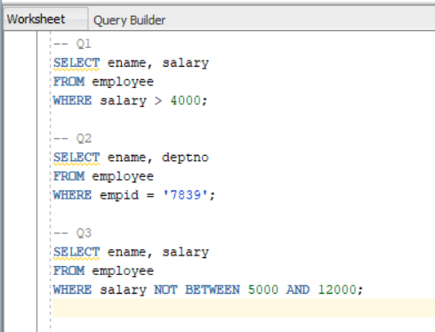
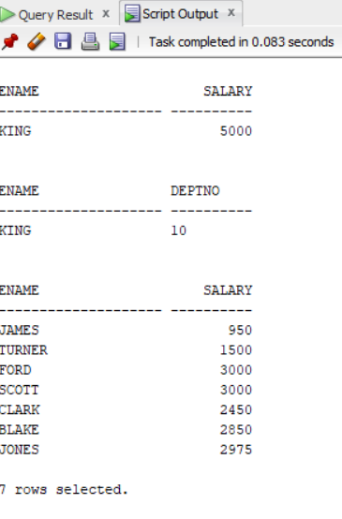

Exercise 4: Display the employee name, job, and hire date of employees hired between February 20, 1998 and May 1, 1998, ordered by hire date in ascending order.
Exercise 5: Display the name and department number of employees in departments 20 and 30, ordered alphabetically by name.
Exercise 6: Display the name and salary of employees earning between $5,000 and $12,000 and working in department 20 or 50, with column aliases Employee and Monthly Salary.
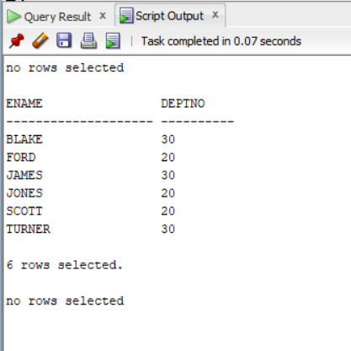
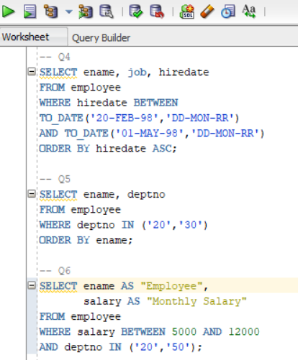

Exercise 7: Display the name and hire date of employees hired in the year 1994.
Exercise 8: Display the name and job title of employees who do not have a manager.

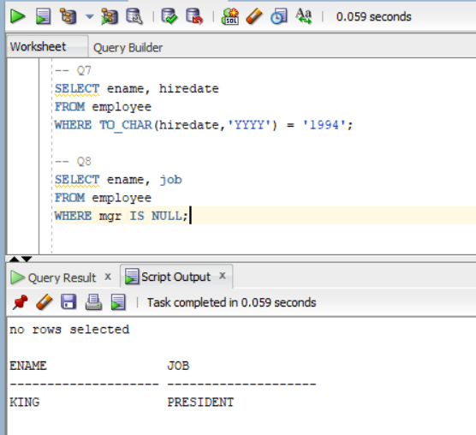

Exercise 9: Display the name, salary, and commission of employees who earn commission, sorted in descending order of salary and commission.
Exercise 10: Display the names of employees whose third letter is ‘a’.
Exercise 11: Display the names of employees who have both ‘a’ and ‘e’ in their name.
Exercise 12: Display the name, job, and salary of employees whose job is Salesman or Clerk and whose salary is not equal to $2,500, $3,500, or $800.

